Viji Vijayan

4/7/2019

Assignment Day-17

AWS

What are the services that AWS provide?

Amazon Web Services (AWS) is a comprehensive, evolving [cloud computing](https://searchcloudcomputing.techtarget.com/definition/cloud-computing) platform provided by Amazon. AWS launched in 2006 from the internal infrastructure that Amazon.com built to handle its online retail operations. More than 200 services comprise the Amazon Web Services portfolio, including those for compute, databases, infrastructure management, application development and security.

**Compute**

1. **EC2 (Elastic Compute Cloud) —**These are just the virtual machines in the cloud on which you have the OS level control. You can run whatever you want in them.
2. **LightSail —**If you don’t have any prior experience with AWS this is for you. It **automatically deploys** and manages compute, storage and networking capabilities required to run your applications.
3. **ECS (Elastic Container Service) —**It is a highly scalable container service to allows you to run Docker containers in the cloud.

**Storage**

1. **S3 (Simple Storage Service) —**Storage service of AWS in which we can store objects like files, folders, images, documents, songs, etc. It cannot be used to install software, games or Operating System.
2. **EFS (Elastic File System) —**Provides file storage for use with your EC2 instances. It uses NFSv4 protocol and can be used concurrently by thousands of instances.
3. **Glacier —**It is an extremely low-cost archivalservice to store files for a long time like a few years or even decades.

**Databases**

1. **RDS (Relational Database Service) —**Allows you to run relational databases like MySQL, MariaDB, PostgreSQL, Oracle or SQL Server. These databases are fully managed by AWS like installing antivirus and patches.
2. **Neptune —**It has been launched recently. It is a fast, reliable and scalable graph database service.
3. **RedShift —**It is AWS’s data warehousingsolution that can be used to run complex OLAP queries.

**Migration**

1. **DMS (Database Migration Service) —**It can be used to migrate on-site databases to AWS. It also allows you to migrate from one type of database to another. Eg -from Oracle to MySQL.
2. **SMS (Server Migration Service)** — It allows you to migrate on-site servers to AWS easily and quickly.
3. **Snowball** — It is a briefcase sized appliance that can be used to send terabytes of data inside and outside of AWS.

**Networking & Content Delivery**

1. **VPC (Virtual Private Cloud) —**It is simply a data center in the cloud in which you deploy all your resources. It allows you to better isolate your resources and secure them.
2. **CloudFront** -It is AWS’s Content Delivery Network (CDN) that consists of Edge locations that cache resources.
3. **Route53** — It is AWS’s highly available DNS (Domain Name System) service. You can register domain names through it.

**Developer Tools**

1. **CodeStar** — It is a cloud-based service for creating, managing, and working with software development projects on AWS. You can quickly develop, build, and deploy applications on AWS with an AWS CodeStar project.
2. **CodeCommit** — It is AWS’s version control service that allows you to store your code and other assets privately in the cloud.
3. **CodeBuild** — It automates the process of building (compiling) your code.

**Management Tools**

1. **CloudWatch** — It can be used to monitor AWS environments like CPU utilization of EC2 and RDS instances and trigger alarms based on different metrics.
2. **CloudFormation** — It is a way of turning infrastructure into the cloud. You can use templates to provision a whole production environment in minutes.
3. **CloudTrail** — A way of auditing AWS resources. It logs all changes and API calls made to AWS.

**Analytics**

1. **Athena** — Allows you to runSQL queries on your S3 bucket to find files.
2. **EMR (Elastic Map Reduce)**— It is used for big data processing like Hadoop, Apache Spark, and Splunk, etc.
3. **CloudSearch** — It can be used to create a fully managed search engine for your website.

**Security, Identity, and Compliance**

1. **IAM (Identity and Access Management)** — Allows you to manage users, assign policies, create groups to manage multiple users.
2. **Inspector** — It is an agent that you install on our virtual machines, which then reports any security vulnerabilities.
3. **Certificate Manager** — It gives free SSL certificates for your domains that are managed by Route53.

**Application Services**

1. **Step Functions** — A way of visualizing what’s going inside your application and what different microservices it is using.
2. **SWF (Simple Workflow Service)** — A way of coordinating both automated tasks and human-led tasks.
3. **SNS (Simple Notification Service)** — Can be used to send you notifications in the form of email and SMS regarding your AWS services. It is a push-based service.

**Mobile Services**

1. **Mobile Hub**— Allows you to add, configure and design features for mobile apps. It is a console for mobile app development.
2. **Cognito** — Allows your users to signup using social identity providers.
3. **Device Farm** — Enables you to improve quality of apps by quickly testing on hundreds of mobile devices.

**Business Productivity**

1. **Alexa for Business** — It lets you empower your organization with voice, using Alexa. Allows you tobuildcustomvoice skillsfor your organization.
2. **Chime** — Can be used for online meeting and video conferencing.
3. **WorkDocs** — Helps to store documents in the cloud

**Desktop & App Streaming**

1. **WorkSpaces** — It is a VDI (Virtual Desktop Infrastructure). Allows you to use remote desktops in the cloud
2. **AppStream 2.0**— A way ofstreaming desktop applications to your users in the web browser. Eg: Using MS Word in Google Chrome.

**Artificial Intelligence**

1. **Lex** — Allows you to quickly build chatbots**.**
2. **Polly** — AWS’s text-to-speech service. You can create audio versions of your notes using it.
3. **Machine learning** — You just have to give your dataset and target variable and AWS will take care of training your model.

**AR & VR (Augmented Reality & Virtual Reality)**

**Sumerian** — It is a set of tools for creating high-quality virtual reality (VR) experiences on the web. You can quickly create interactive 3D scenes and publish it as a website for users to access.

**Customer Engagement**

1. **Amazon Connect** — Allows you to create a customer care center in the cloud.
2. **Pinpoint** — It is like Google analytics for mobile applications. It helps you to understand users and engage with them.
3. **SES (Simple Email Service)** — Allows you to send bulk emails to your customers at an extremely low price.

**Game Development**

**GameLift** — It is a service managed by AWS that can used to host dedicated game servers. It seamlessly scales without taking your game offline.

**Internet of Things**

1. **IoT Core**— It is a managed cloud platform that lets connected devices — cars, light bulbs, sensor grids, and more — easily and securely interact with cloud applications and other devices.
2. **IoT Device Management**— Allows you to manage your IoT devices at any scale.
3. **IoT Analytics** — Can be used to perform analysis on data collected by your IoT devices.

Difference between AWS and Google cloud

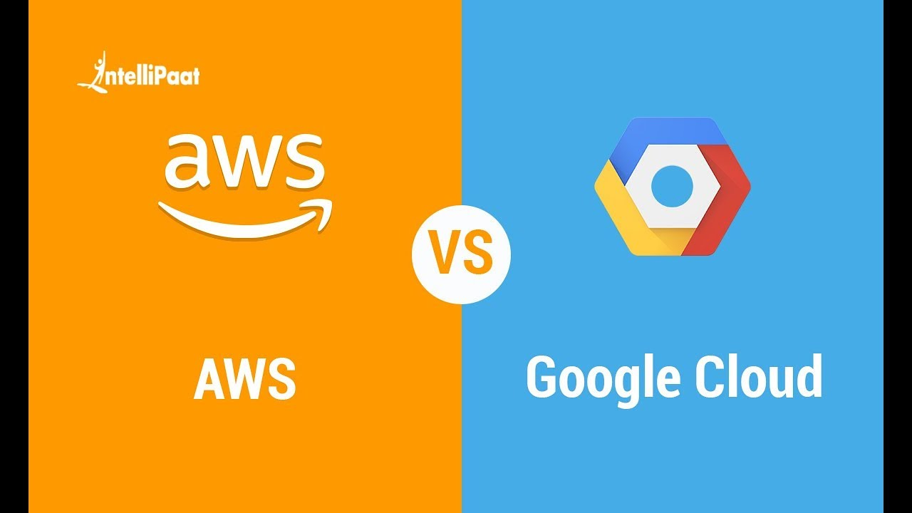

|  |  |  |
| --- | --- | --- |
| Launched | 2006 | 2011 |
| Availability zones | >55 | >18 |
| Market shares | 40% | 10% |
| Popularity | Due to its more experience, has bigger community support and trust across its clients. (Netflix, BMW, Samsung, etc.) | Even though it’s a new comer, as it shares same infrastructure that of google search engine and Youtube many big companies have faith on them (Paypal, HSBC, Dominos, etc.) |
| Services covered | 200+ | 60+ |
| Speed | Slower than GCP | Faster than AWS |
| Pricing | Basic: 2vCPUs+8 GB RAM= approx. 69USD/month  Highest: 3.84TB RAM+128 vCPUs= approx. 3.97/hr | Basic: 2vCPUs+8 GB RAM= approx. 52USD/month  Highest: 3.75TB RAM+160 vCPUs= approx. 5.32/hr |